PRE READING ACTIVITIES
Join with the correct meaning:
FOND: fanático (a)
EVERYWHERE: donde sea
TOURNAMENTS: torneos
QUITE: bastante, muy
DREAM: sueño, soñar
SUCCESSFUL: exitoso (a)
PLAYER: jugador (ra)
TEAM: equipo
MATCH: partido

PARTIDO
EQUIPO
JUGADOR (RA)
EXITOSO (A)
SOÑAR
BASTANTE, MUY
TORNEOS
DONDE SEA
FANÁTICO (A)

My Favourite Sport
What do you think the reading is about?
□ A family trip
□ Basketball Andrea
□ School
□ A favourite sport Amanda
□ A pet
□ A basketball player Isidora

Predict True or False
Before reading, write T or F
Sentence | Prediction
Jordan doesn’t like sports. | _F____
His favorite sport is football | __F___
He trains every day. | _T____
He likes reading. | _F____
He wants to be a basketball player. | _T____
👉 After reading, compare your predictions with the answers.

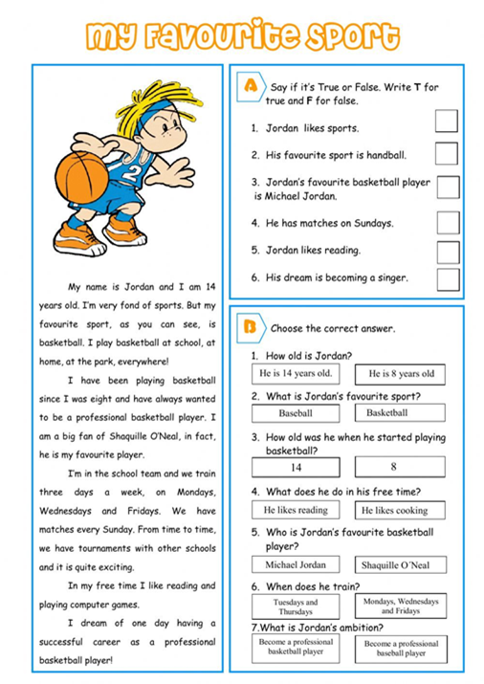
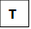
F
T
T
F
F
T

