PRE READING ACTIVITIES
Join with the correct meaning:
FOND: fanático (a)
EVERYWHERE: donde sea
TOURNAMENTS: torneos
QUITE: bastante, muy
DREAM: sueño, soñar
SUCCESSFUL: exitoso (a)
PLAYER: jugador (ra)
TEAM: equipo
MATCH: partido



PARTIDO
EQUIPO
JUGADOR (RA)
EXITOSO (A)
SOÑAR
BASTANTE, MUY
TORNEOS
DONDE SEA
FANÁTICO (A)

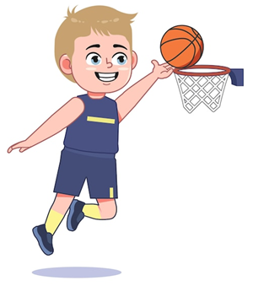

My Favorite Sport
What do you think the reading is about?
□ A family trip
□ Basketball Andrea
□ School
□ A favorite sport Amanda
□ A pet
□ A basketball player Isidora

Predict True or False
Before reading, write T or F
Sentence | Prediction
Jordan doesn’t like sports. | _F__good__
His favorite sport is football | __F__good_
He trains every day. | _T__bad__
He likes reading. | _F__bad__
He wants to be a basketball player. | _T___good_
👉 After reading, compare your predictions with the answers.

AFTER READING ACTIVITIES
Activity 1 – Answer the Questions
Answer in complete sentences.
- What is Jordan's favorite sport?
His favorite sport is basketball
- Where does Jordan play basketball?
He plays basketball at school, home, park
- How old was Jordan when he started playing basketball?
He was 8 years old
- Who is Jordan's favorite basketball player?
O’Neal
- How many days does Jordan train every week?
Three days a week
- What does Jordan like to do in his free time?
He likes reading
- What is Jordan's dream?
His dream is to be a profession basketball player

Activity 2 – Complete the Information
Fill in the chart.
Information | Answer
Name | __Jordan________________
Age | ___14 years old_________
Favorite sport | ___basketball____________
Favorite player | ___O’Neal_______________
Trains on | ___Mondays, Fridays and wednesday
Free time activities | ___reading_______________
Dream | __become a professional basketball _player__________
Activity 3 – Order the Events
Number the sentences from 1 to 5.
_____ Jordan dreams of becoming a professional basketball player.
____Jordan plays basketball at school and at home.
_____ Jordan started playing basketball when he was eight.
____ Jordan trains three days a week.
_____ Jordan likes reading and playing computer games.

*Activity 4 – Writing
Complete the paragraph.
My favorite Sport
My name is ___Mari_______________.
I am _46_____ years old.
My favorite sport is __do gymnastics_______.
I play __on Mondays_, Wednesdays and Fridays__.
In my free time, I like __watching TV___.
My favorite athlete is _I don’t have one________.
My dream is for my son to be happy_____.
I don’t have any dream yet

*FINAL ACTIVITY
Answer in one sentence.
- What did you learn today? (en español)
👉 ________________________________________
- What new word did you learn?
👉 ________________________________________
- What is your favorite sport?
👉 ________________________________________

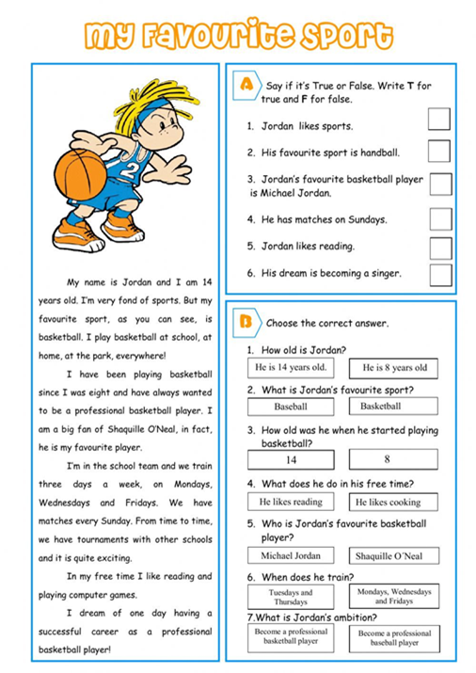
F
T
T
F
F
T

