- https://www.yout-ube.com/watch?v=LwyclIWCldI
After watching the video, create sentences in affirmative, negative and make a question to me in past tense

- S + v(past) + c
- S + didn’t + v(normal) +c
- (Q.W) Did + S + v(normal) c?

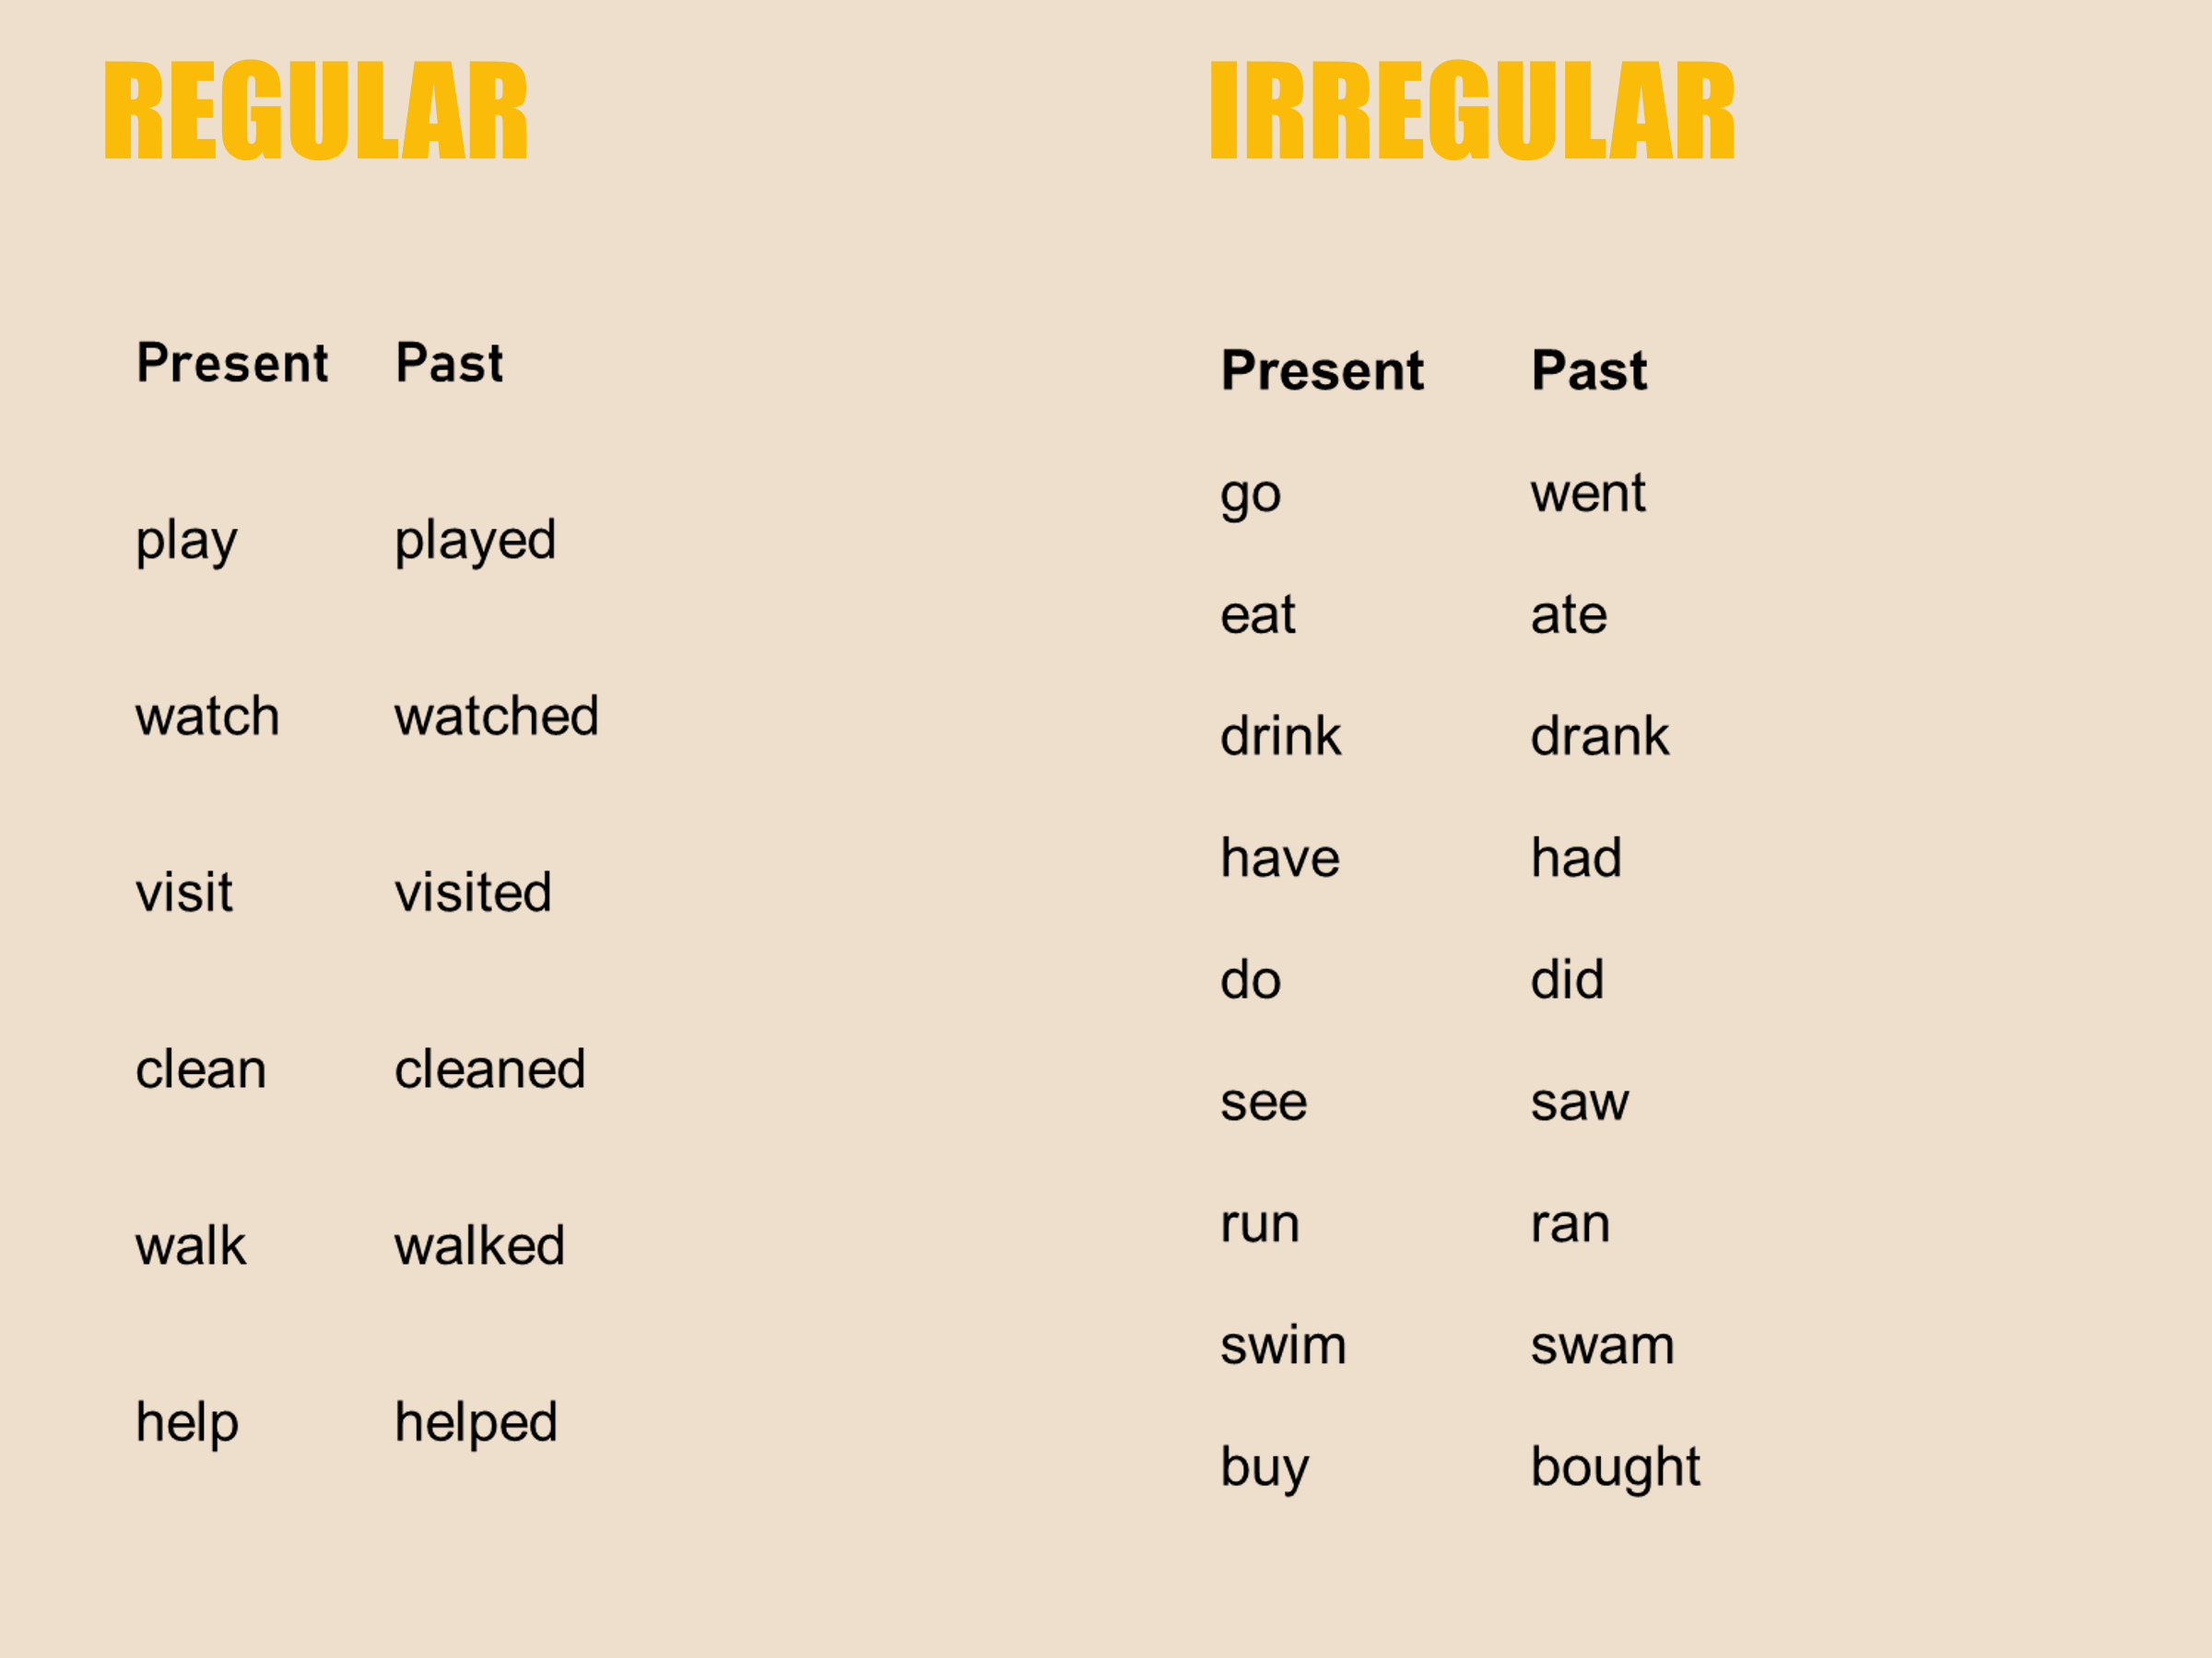

VOCABULARY BEFORE READING

- Fall out : Tropezar o caerse.
- Sprain (an ankle): Torcerse o esguinzarse (un tobillo).
- Slip: Resbalar / Resbalarse.
- Break (a leg): Romper / fracturarse (una pierna).
- Faint: Desmayarse.
- Get sick / Feel sick: Enfermarse / Sentirse mal.
- Hurt (a knee): Lastimarse / Hacerse daño (en la rodilla).

• Blisters: Ampollas (en los pies).
• Rafting: Canotaje / Descenso de ríos.
• Trekking: Senderismo / Caminata por la montaña.
• Ski resort: Centro de esquí.
• Tornado: Tornado.

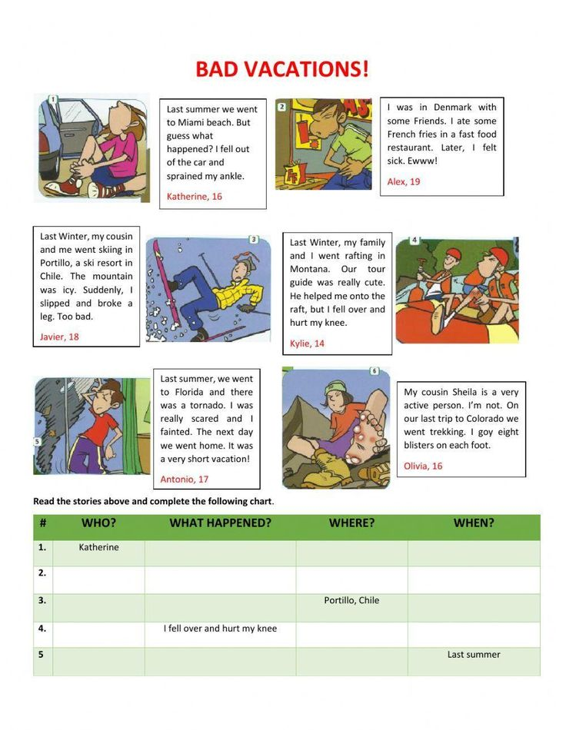

EXERCISES
TRUE OR FALSE: correct the false ones
- Katherine went to Miami Beach last winter. F She went there last summer
- Alex felt sick in Denmark after eating fast food. T
- Javier broke his arm while skiing in Portillo. F. He broke his leg
- Kylie’s tour guide in Montana was helpful when she hurt her knee. T
- Antonio's family stayed in Florida for a long vacation after the tornado. F. They stayed for a short vacation
- Olivia is a very active person who loves trekking. F Olivia is not an active person

- A. Katherine 1. Got 8 blisters on each foot.
- B. Alex 2. Fainted because of a tornado.
- C. Javier 3. Sprained an ankle falling out of the car.
- D. Kylie 4. Ate bad food and felt sick.
- E. Antonio 5. Slipped on icy mountain and broke a leg.
- F. Olivia 6. Fell over onto the raft and hurt her knee.

